**TASK 21 OUTPUT:**

**1.Erasing the text and printing the given text:**

**STEPS PERFORMED ARE:**

1.Opened the chrome browser

2.Navigated to <https://the-internet.herokuapp.com/iframe>.

3.Maximised the browser window.

4.Switched to the frame.

5.Locators are used to find the element <p> is used to find the element using xpath and the content is cleared using clear method.

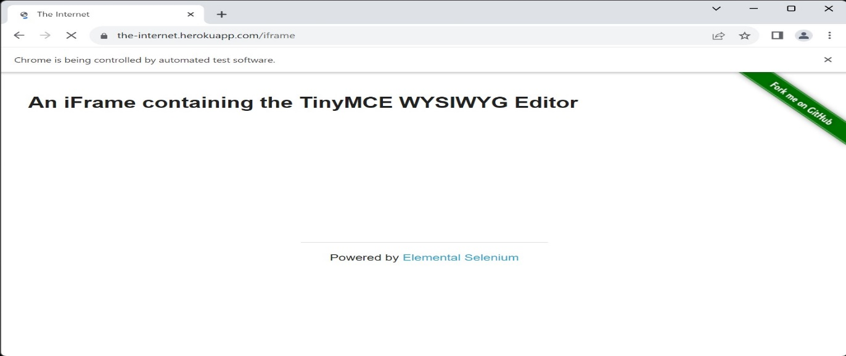

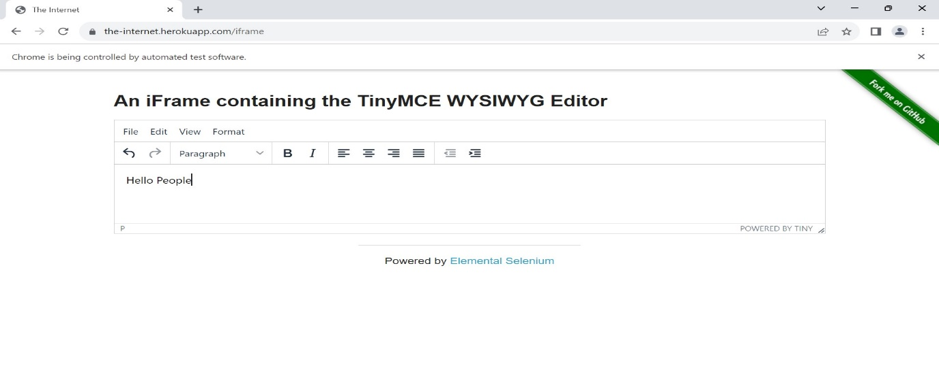

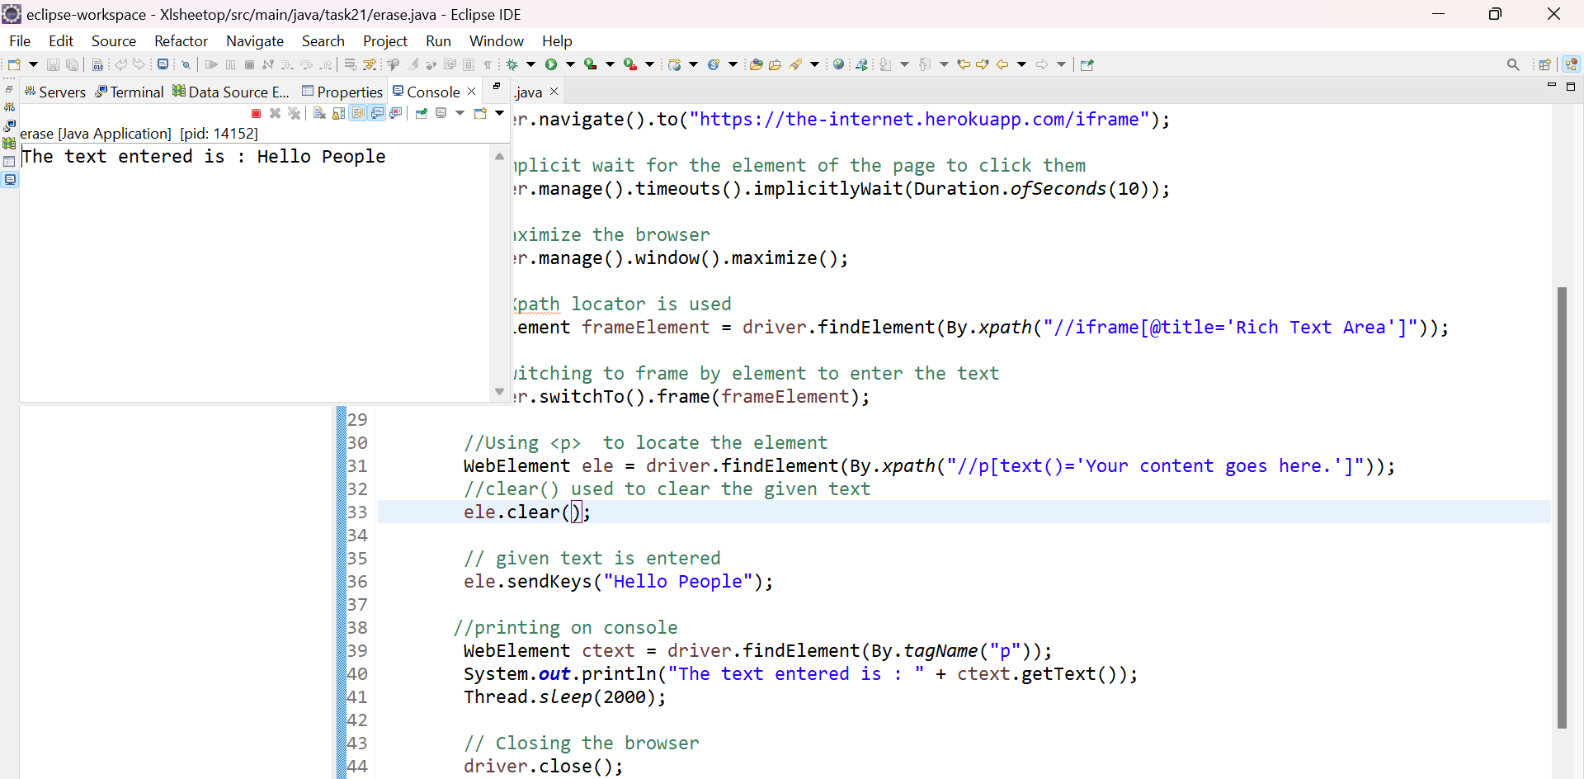

6.Browser is quitted.

7.Finally the text is printed on the console.

**2. Switching to parent and child window:**

**STEPS PERFORMED ARE:**

1.Opened the chrome browser

2.Navigated to <https://the-internet.herokuapp.com/iframe>.

3.Maximised the browser window.

4. Locators are used and **click here** is inspected.

5.Using the index child window’s path is tracked.

6.Validation is done for new opened window.

7.Driver is closed.

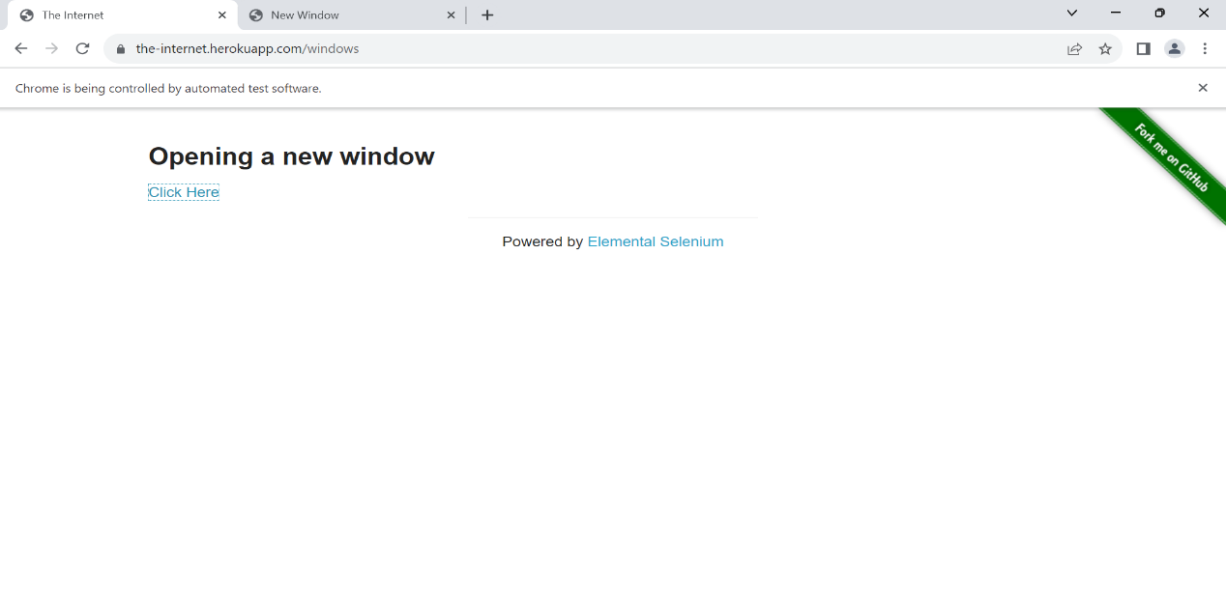

8. Validation is done for parent window to know whether it is active or not.

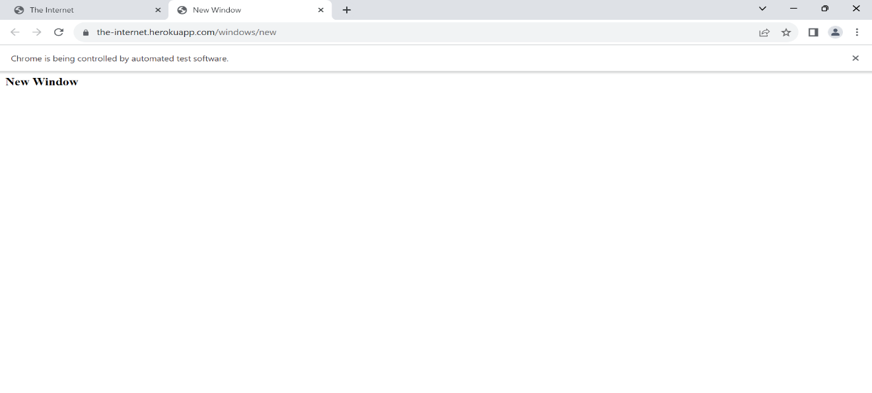

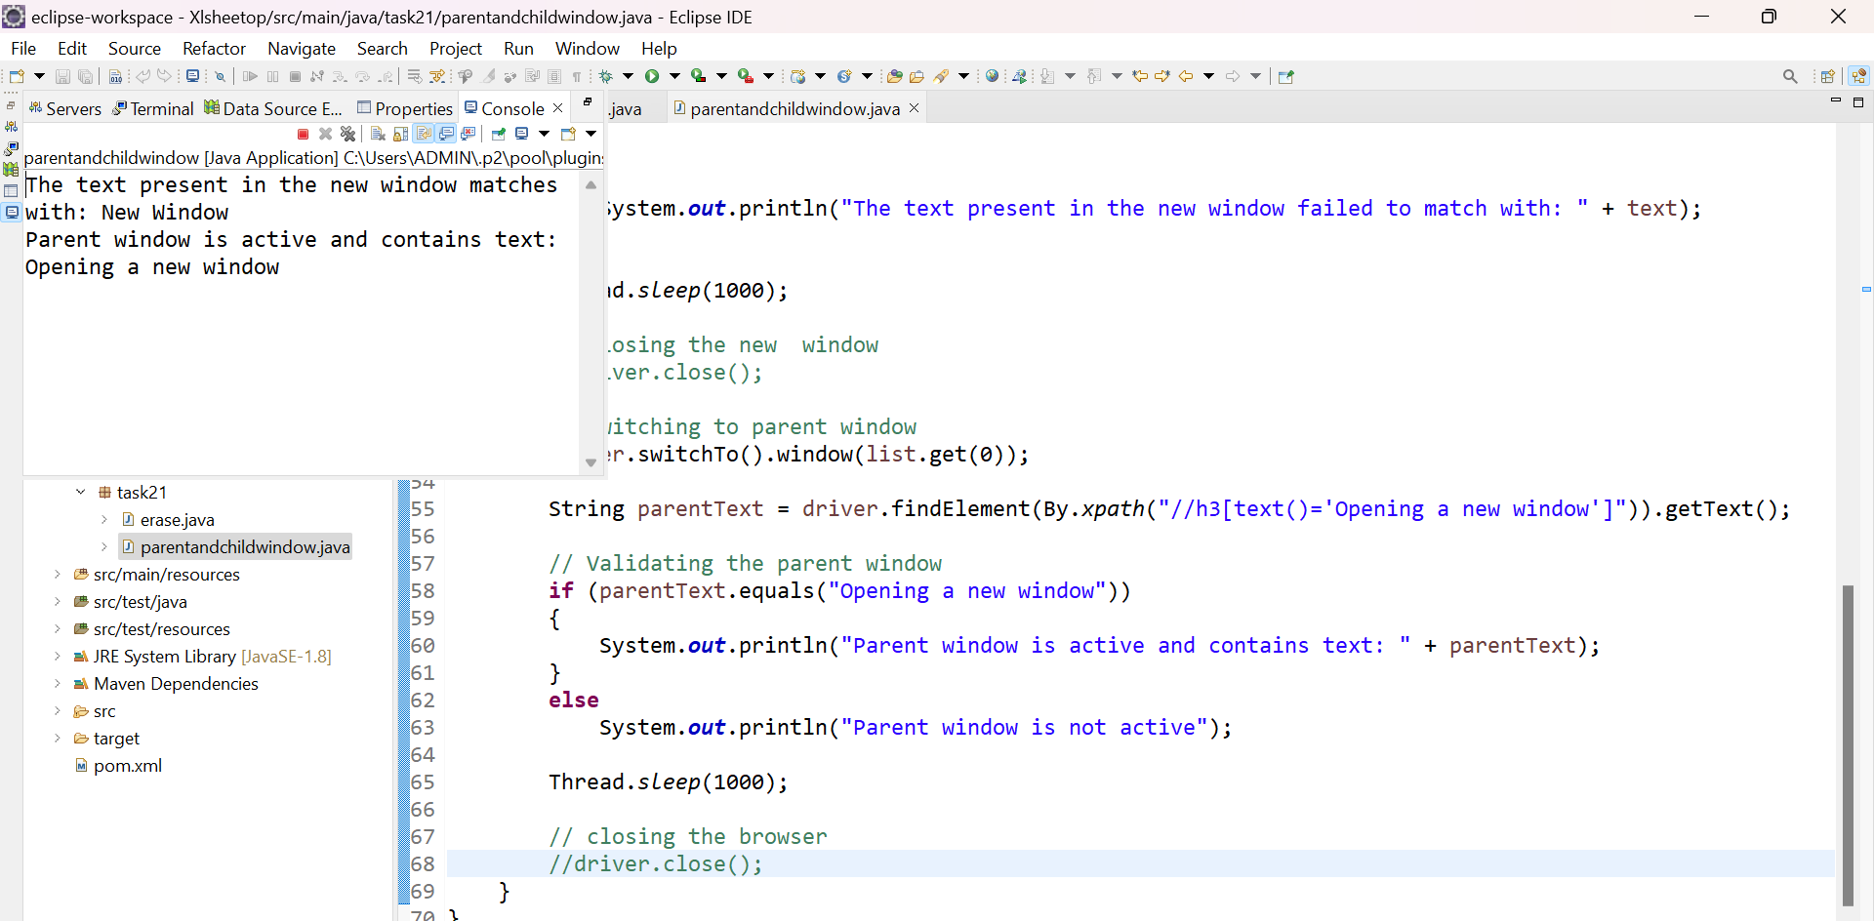

9.Driver is closed.

**3. Nested frame**

**STEPS PERFORMED ARE:**

1.Opened the chrome browser

2.Navigated to <http://the-internet.herokuapp.com/nested_frames>

3.Maximised the browser window.

4.Xpath is used to switch to the top frame.

5.Three frames are verified using the condition.

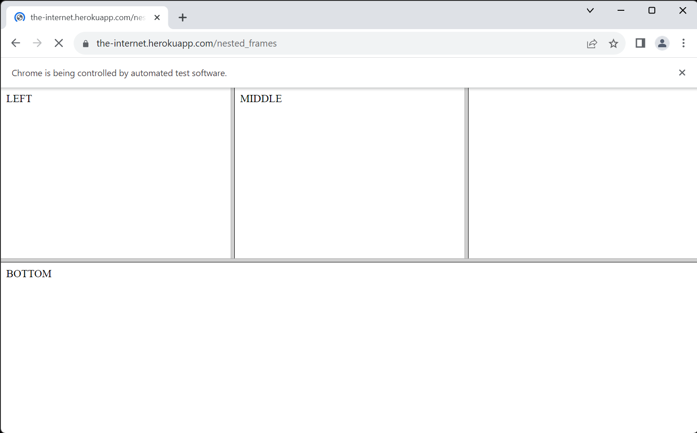

6.Left frame is verified and validated using condition.

7.Switched to the top frame.

8.Middle frame is verified and validated using condition.

9.Switched to the top frame.



10.Browser is closed.